T&L Instructional Plan Template
(Updated 4/17/15)
(edTPA Aligned)

Overview
The information included in this document is to support faculty in teaching about and supporting students with the T&L (and edTPA) Instructional Plan. While there are many variations of lesson plans, this format meets departmental requirements and is aligned with the 2014 edTPA as well.

Background Information (When doing the actual edTPA, leave out identifiers)

Teacher Candidate: Kayla Davis Date: 9/27/2016
Cooperating Teacher: Patty May Grade: 4th/ 5th
School District: Longview School: Columbia Heights Elementary
University Supervisor: Lisa Swindell
Unit/Subject: English Language Arts
Instructional Plan Title/Focus: Cause and Effect

Section 1: Planning for Instruction and Assessment

a. Instructional Plan Purpose: The purpose of this lesson is to help students understand cause and effect relationships so that they can identify these relationships while they are reading an informational text. With this, the goal for students is also that they will be able to successfully record the cause and effect relationships they identify in a text into a graphic organizer.

The 4th grade students recently finished Lesson 2 in the Journeys curriculum. This lesson focused on civil rights and what might cause a person to try to change the world. Additionally, in this lesson, students learned about author’s purpose. The 4th graders will review cause and effect (from Lesson 3) again tomorrow after today’s lesson and will continue to work on identifying cause and effect relationships in texts they are reading. They will then work on answering the essential question that relates Lesson 3 in their textbooks: “Why are books and libraries important to people and communities?”

The 5th grade students recently finished Lesson 5 in the Journeys curriculum. This lesson focused on the environment and situations that might cause people to try to protect it. Additionally, in this lesson, students learned about author’s purpose. The 5th graders will review cause and effect (from Lesson 6) again tomorrow after today’s lesson and will continue to work on identifying cause and effect relationships in texts they are reading. They will then work on answering the essential question that relates to Lesson 6 in their textbooks: “What might cause people to try to protect the environment?”

- State/National Learning Standards:
4th Grade
CCSS.ELA-LITERACY.RI.4.5
Describe the overall structure (e.g., chronology, comparison, cause/effect, problem/solution) of events, ideas, concepts, or information in a text or part of a text.

CCSS.ELA-LITERACY.L.4.6
Acquire and use accurately grade-appropriate general academic and domain-specific words and phrases, including those that signal precise actions, emotions, or states of being (e.g., quizzed, whined, stammered) and that are basic to a particular topic (e.g., wildlife, conservation, and endangered when discussing animal preservation).

CCSS.ELA-LITERACY.SL.4.1.D
Review the key ideas expressed and explain their own ideas and understanding in light of the discussion.

5th Grade
CCSS.ELA-LITERACY.RI.5.3
Explain the relationships or interactions between two or more individuals, events, ideas, or concepts in a historical, scientific, or technical text based on specific information in the text.

CCSS.ELA-LITERACY.L.5.6
Acquire and use accurately grade-appropriate general academic and domain-specific words and phrases, including those that signal contrast, addition, and other logical relationships (e.g., however, although, nevertheless, similarly, moreover, in addition).
(Note: This lesson is designed for a split classroom with both 4th and 5th grade students. Therefore, the learning standards reflect both grade levels).

CCSS.ELA-LITERACY.SL.5.1.D
Review the key ideas expressed and draw conclusions in light of information and knowledge gained from the discussions.

- Content Objectives (to be copied in Assessment Chart below) and alignment to State Learning Standards:

1. SWBAT understand cause and effect relationships.

Aligned standard: CCSS.ELA-LITERACY.RI.5.3; CCSS.ELA-LITERACY.RI.5.3

- SWBAT identify cause and effect relationships in an informational text.

Aligned standard: CCSS.ELA-LITERACY.RI.5.3; CCSS.ELA-LITERACY.RI.5.3

- SWBAT use a graphic organizer to record cause and effect relationships that they identify while reading an informational text.

Aligned standard: CCSS.ELA-LITERACY.RI.5.3; CCSS.ELA-LITERACY.RI.5.3

Language Objectives:
1. SWBAT define the terms “cause” and “effect”

Aligned standard: CCSS.ELA-LITERACY.L.4.6; CCSS.ELA-LITERACY.L.5.6

2. SWBAT explain cause and effect relationships in their own words with specific examples

Aligned standard: CCSS.ELA-LITERACY.SL.4.1.D; CCSS.ELA-LITERACY.SL.5.1.D

- Previous Learning Experiences: Both 4th and 5th grade students are familiar with using graphic organizers – specifically T-charts, which will be used in this lesson. Students are also familiar with reading informational texts and referring to texts for the purpose of answering questions or practicing different strategies such as compare/contrast.

- Planning for Student Learning Needs (accommodations, student experiences, prior learning and experiences):

Hearing Impaired – Seated close to the front of the class. All students will have access to visual cues.
Struggling Learners with Learning Disabilities related to ELA – Teacher reading the text aloud while providing a variety of kinesthetic and visual examples to relay concepts to students.
ELL Student – Providing visual and kinesthetic learning examples for all students.
Other Health Impaired – Interactive learning throughout lesson to keep students’ attention.

f. Assessment Strategies (Informal and formal):
Content/Language Objectives | Assessment Strategies
Content: SWBAT understand cause and effect relationships. | Informal: The teacher will note student responses during whole group instruction to gauge understanding.  Formal: The teacher will collect students’ reading spiral notebooks to view their cause and effect T-charts.
Content: SWBAT identify cause and effect relationships in an informational text. | Formal: The teacher will collect students’ reading spiral notebooks to view their cause and effect T-charts.
Content: SWBAT use a graphic organizer to record cause and effect relationships that they identify while reading an informational text. | Formal: The teacher will collect students’ reading spiral notebooks to view their cause and effect T-charts.
Language: SWBAT define the terms “cause” and “effect” | Informal: Students will define the terms during whole group instruction accompanied with kinesthetic movements.
Language: SWBAT explain cause and effect relationships in their own words with specific examples | Informal: Collect exit slips where students will explain cause and effect and provide an example of the relationship.

g. Student Voice
K-12 students will be able to: | Student-based evidence to be collected (things produced by students: journals, exit slips, self-assessments, work samples, projects, papers, etc.) | Description of how students will reflect on their learning.
- Explain student learning targets and what is required to meet them (including why they are important to learn). | Student Exit Slip | Students will write and explain the goals of the lesson in their own words and why it is important to meet them.
- Monitor their own learning progress toward the learning targets using the tools provided (checklists, rubrics, etc.). | Student Exit Slip | Students will rate their overall learning and understanding of each target after the lesson. 4 being that they understood it very well; 3 being that they understood it, but sometimes got stuck; 2 being that they are starting to get it but still need help; and 1 being that they really don’t understand it yet.
- Explain how to access resources and additional support when needed (and how/why those resources will help them). | Student Exit Slip | Students will list resources they can access for additional support including their student math books and “Think Central” online.
- Grouping of Students for Instruction:
Whole Group Instruction: Students will be grouped for whole-group instruction for the duration of the lesson until instruction has reached the “You do” portion of the gradual release of responsibility model. At this point, students will work at the target skill independently – that is, identifying cause and effect relationships.
Independent Practice: After whole group instruction, students will work independently to identify cause/effect relationships in their grade level informational text. 4th graders will use the text “My Librarian is a Camel” in their Journeys (ELA) book and 5th graders will use the text “Quest for the Tree Kangaroo” in their Journeys (ELA) book.

Section 2: Instruction and Engaging Students in Learning

- Introduction: The teacher will introduce the lesson focus: cause and effect, to the class along with the learning targets. Then the instructor will explain that “cause” is an event that makes another event happen and “effect” is an event that happens because of the cause. Next, to engage students, the teacher will lead the class in a kinesthetic movement exercise that helps students do and see what cause and effect means. First, the instructor will tell the class to copy their actions and repeat their words. They will hold up their right hand and say “cause” and the class will mirror and repeat. While, still holding their right hand in the air, the instructor will say, “is the first thing that happens”. The class will repeat. Next, while still holding their right hand in the air, the instructor will raise their left hand in the air and say “effect” and the class will mirror and repeat. Then the instructor will clap their left palm down with their right hand. The class will mirror. Then the instructor will say “happens because of the cause”. The class will repeat. After the class has gone through this exercise once, the instructor will explain how the exercise shows and explains cause and effect. Then they will repeat the exercise with students another 2-3 times – looking to make sure all students are actively engaged.

- Questions:
- What did you just see happen? How can you relate this to cause and effect? (Domino activity) (Understand)
- What is an informational text? (Remember)
- What cause and effect relationships can you find in this specific paragraph (located in “The Earthquake that Changed Earth”)? (Analyze)
- What key words help signal that we are seeing a cause and effect relationship when we are reading? (Remember)
- Why is understanding cause and effect important? (Analyze)

c.jkLearning Activities:
Learning Steps and Activities | Supporting Theories/Principles  (Why are you doing what you are doing?)
- After the introduction, the teacher will use a Cause/Effect T-Chart and visuals to explain cause and effect. The teacher will show the class an image of a banana peel and then place it on the “cause” side of the T-chart. Then the teacher will explain that if there is a banana peel on the floor that someone will probably slip and fall. They will then place an image of someone slipping on a banana peel on the “effect” side of the T-Chart. The teacher will do the same with images of someone blowing bubble gum and the bubble gum popping on their face. | Paivio: Information is stored in long-term memory as either visual images of verbal units.  Support visual learners, as well as hearing- impaired/ELL student.
- The teacher will then stand up two dominoes next to each other on a table in front of the class. They will then push over the first domino | Support visual learners, as well as hearing- impaired/ELL student.
class. They will then push over the first domino and follow up by asking students what they saw and how it relates to cause and effect.
3. The teacher will then explain to students that a cause can have more than one effect. They will then place the pictures of the “man in a wheel chair” and the “man in a wheelchair using a ramp” on the “effect” side of the chart, explaining that these also could have been effects of slipping on a banana peel. They will do the same with the pictures of the “boy getting bubble gum in his hair”, “the bald boy”, and the “no gum sign” on the effect side of the chart as well, explaining that these also could have been effects of blowing bubble gum. | Support visual learners, as well as hearing- impaired/ELL student. Supports student engagement.
4. The instructor will then stand up multiple dominoes in a line on a table in front of the class. They will push over the first domino and then ask students to explain what they saw and how it relates to cause and effect. | Support visual learners, as well as hearing- impaired/ELL student. Supports student engagement.
5. The instructor will tell students that sometimes there also might be more than one cause as well. They will place an image of “wind” and an image of “rain” on the “cause” side of the T-chart. They will then place and image of a damaged house on the “effect” side and explain that both of these causes resulted in the house being destroyed. | Support visual learners, as well as hearing- impaired/ELL student. Supports student engagement.
6. The instructor will then demonstrate multiple causes with dominoes. This time the instructor will set up two dominoes at the front of a line of dominoes. They will push over the two dominoes, which then cause the rest of the dominoes to fall over. Students will explain what they saw and how it relates to cause and effect. | Support visual learners, as well as hearing- impaired/ELL student. Supports student engagement.
7. The teacher will lead students through the kinesthetic exercise from the introduction again. | Constructivism: students are actively participating to learn a new concept.
8. The teacher will then remind students that one of the learning goals is to be able to identify cause and effect relationships in their stories and record them in a T-Chart. They will explain that they will model this for students first. | Ausabel & Mayer: Front-loading students can help students know what is happening in advance.
9. The instructor will tell students that sometimes authors organize their texts by things like similarities or differences or by using cause and effect. They will tell students that they are going to be modeling with an informational text because students will have to identify cause and effect relationships using an informational text later on. | Students will understand the purpose of the chosen text.
10. The teacher will put up “The Earthquake that Changed Earth” underneath the document camera. The instructor will read the text aloud to students the first time. | Easy viewing or students as the teacher reads aloud. The read aloud supports all students’ understanding (especially those with learning disabilities related to reading).
11. Next, the instructor will model in their notebook spiral how to make a cause and effect T-chart (with proper heading). Then they will go back through the document (think aloud) to record cause and effect relationships that they noticed using the gradual release of responsibility model. First, they will read until the sentence “An earthquake happens when two blocks of earth suddenly slip past each other.” Using a think a loud the teacher will note the cause and effect relationship and record it in their chart for students using the document camera. The teacher will do the same with “The shaking was s o strong that people ran out of the buildings they were in”. | Bandura’s Observational Learning: Students learn best through modeling.  Think aloud: Let’s students know what internal processing should be going as they are reading their text.  Gradual Release of Responsibility (I do/We do/You do): When students have tasks modeled for them first, they are more likely to have a better understanding of what to do and are more apt to successfully complete the task on their own when it is time for independent practice.
12. The teacher will read until “Since so many people were already outside when this earthquake hit, not too many people were injured.” They will talk about key words that signal that there is a cause and effect relationship like “since”, “because”, “caused” and “as a result of”. Then they will ask students to help them figure out the cause/effect relationship. They will explain that sometimes it is easier to write down the effect first. The teacher will then read until “When the earth around the epicenter started to shake, the water in the ocean did, too.” Again, asking students to figure out the cause/effect relationship and what they should write down. | Gradual Release of Responsibility (I do/We do/You do): When students have tasks modeled for them first, they are more likely to have a better understanding of what to do and are more apt to successfully complete the task on their own when it is time for independent practice.
13. Brain break: do the kinesthetic exercise with students 1-3 times to give students a brain break and to help them stay engaged. | Students enjoy the kinesthetic exercise and doing this gives them a nice brain break to get them ready to start working at cause/effect relationships on their own.
14. Read until the second to last paragraph. Zoom in on this paragraph using the document camera. Have students make their own cause and effect chart in their spiral notebooks. Explain that they are going to read the paragraph and record two cause/effect relationships that they find. Read the paragraph aloud to students. Then allow time for them to complete the task. (Allow students to come forward to work as needed in order to see better). | Reading aloud supports all students. Giving students the ability to come work closer to the projector allows them the opportunity to be able to see better in order to read.
15. After students have finished the task, ask for volunteers to share some of their findings. Record these on the teacher’s cause/effect chart on the document camera. | Vygotsky: Emphasis that language and communication can help students better process information. This also supports students who may have struggled during independent practice – to hear the sharing of other students’ ideas.

d. Closure: At the end of the lesson, the teacher will revisit the learning targets and review cause and effect by taking the class through the kinesthetic movement exercise again for review. The teacher will then introduce the activity that students will be working on independently at their desks. Grade 4 students will use the text “My Librarian is a Camel” on page 79 of their Journeys book and grade 5 students will use the text “Quest for the Tree Kangaroo” in page 175 of their Journeys book. Using these texts, students will use a “Cause and Effect” T-Chart in their reading spiral notebook to record two cause and effect relationships that they find during their reading. Before students begin, the teacher will ask students to recall what key words they can look for to signal cause and effect relationships for review and remind students of the modeling that they did for students on the projector with “The Earthquake that Changed the World.” Introduce independent practice and additional resources. Students will then work independently to record cause and effect relationships that they identify while they are reading and complete exit slips.

e.kIndependent Practice: Students will extend their experiences with cause and effect outside of class by writing down cause and effect relationships that they identify when reading their own personal texts when completing their reading log over the course of the rest of the week. Students will also be encouraged to be more aware during their everyday life to note cause and effect that happens to or around them. They can then share these experiences with the class during a “share-out” lunch day.

f. Instructional Materials, Resources, and Technology:
- Projector
- Whiteboard (for writing learning targets)
- Dry erase marker
- Chart paper with “Cause and Effect” T-Chart
- “Cause and Effect” Images
- Dominoes (6-8)
- Copy of “The Earthquake that Changed Earth”
- Spiral Notebook (for modeling writing for students)
- Reading Spiral Notebooks (1 per student)
- Journeys Grade 4 and Grade 5 teacher and student edition
- Exit Slips

g. Acknowledgements

Common Core: State Standards Initiative. (n.d.) Retrieved from http://www.corestandards.org.

(2014). Journeys: Common Core Grade 4/5. Houghton Mifflin Harcourt. (This lesson was adapted from the grade 4 and grade 5 Journeys textbooks)

Lakeshore Learning. (n.d.) The Earthquake that Changed Earth. Retrieved from
https://www.lakeshorelearning.com/media/images/free_resources/teachers_corner/lesson_plans/3_4/lessonCauseEffectFull.pdf

Thorbahn, Tonya. (2013). Whole Brain Teaching: Cause and Effect. (Cause and Effect whole class kinesthetic exercise)

WSU College of Ed. (n.d.). Learning Theory in the Classroom. Retrieved from
https://education.wsu.edu/documents/2015/09/learning-theory-in-the-classroom.pdf.

*Cause and Effect Images (Resize as needed)
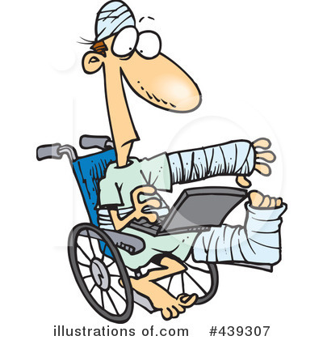
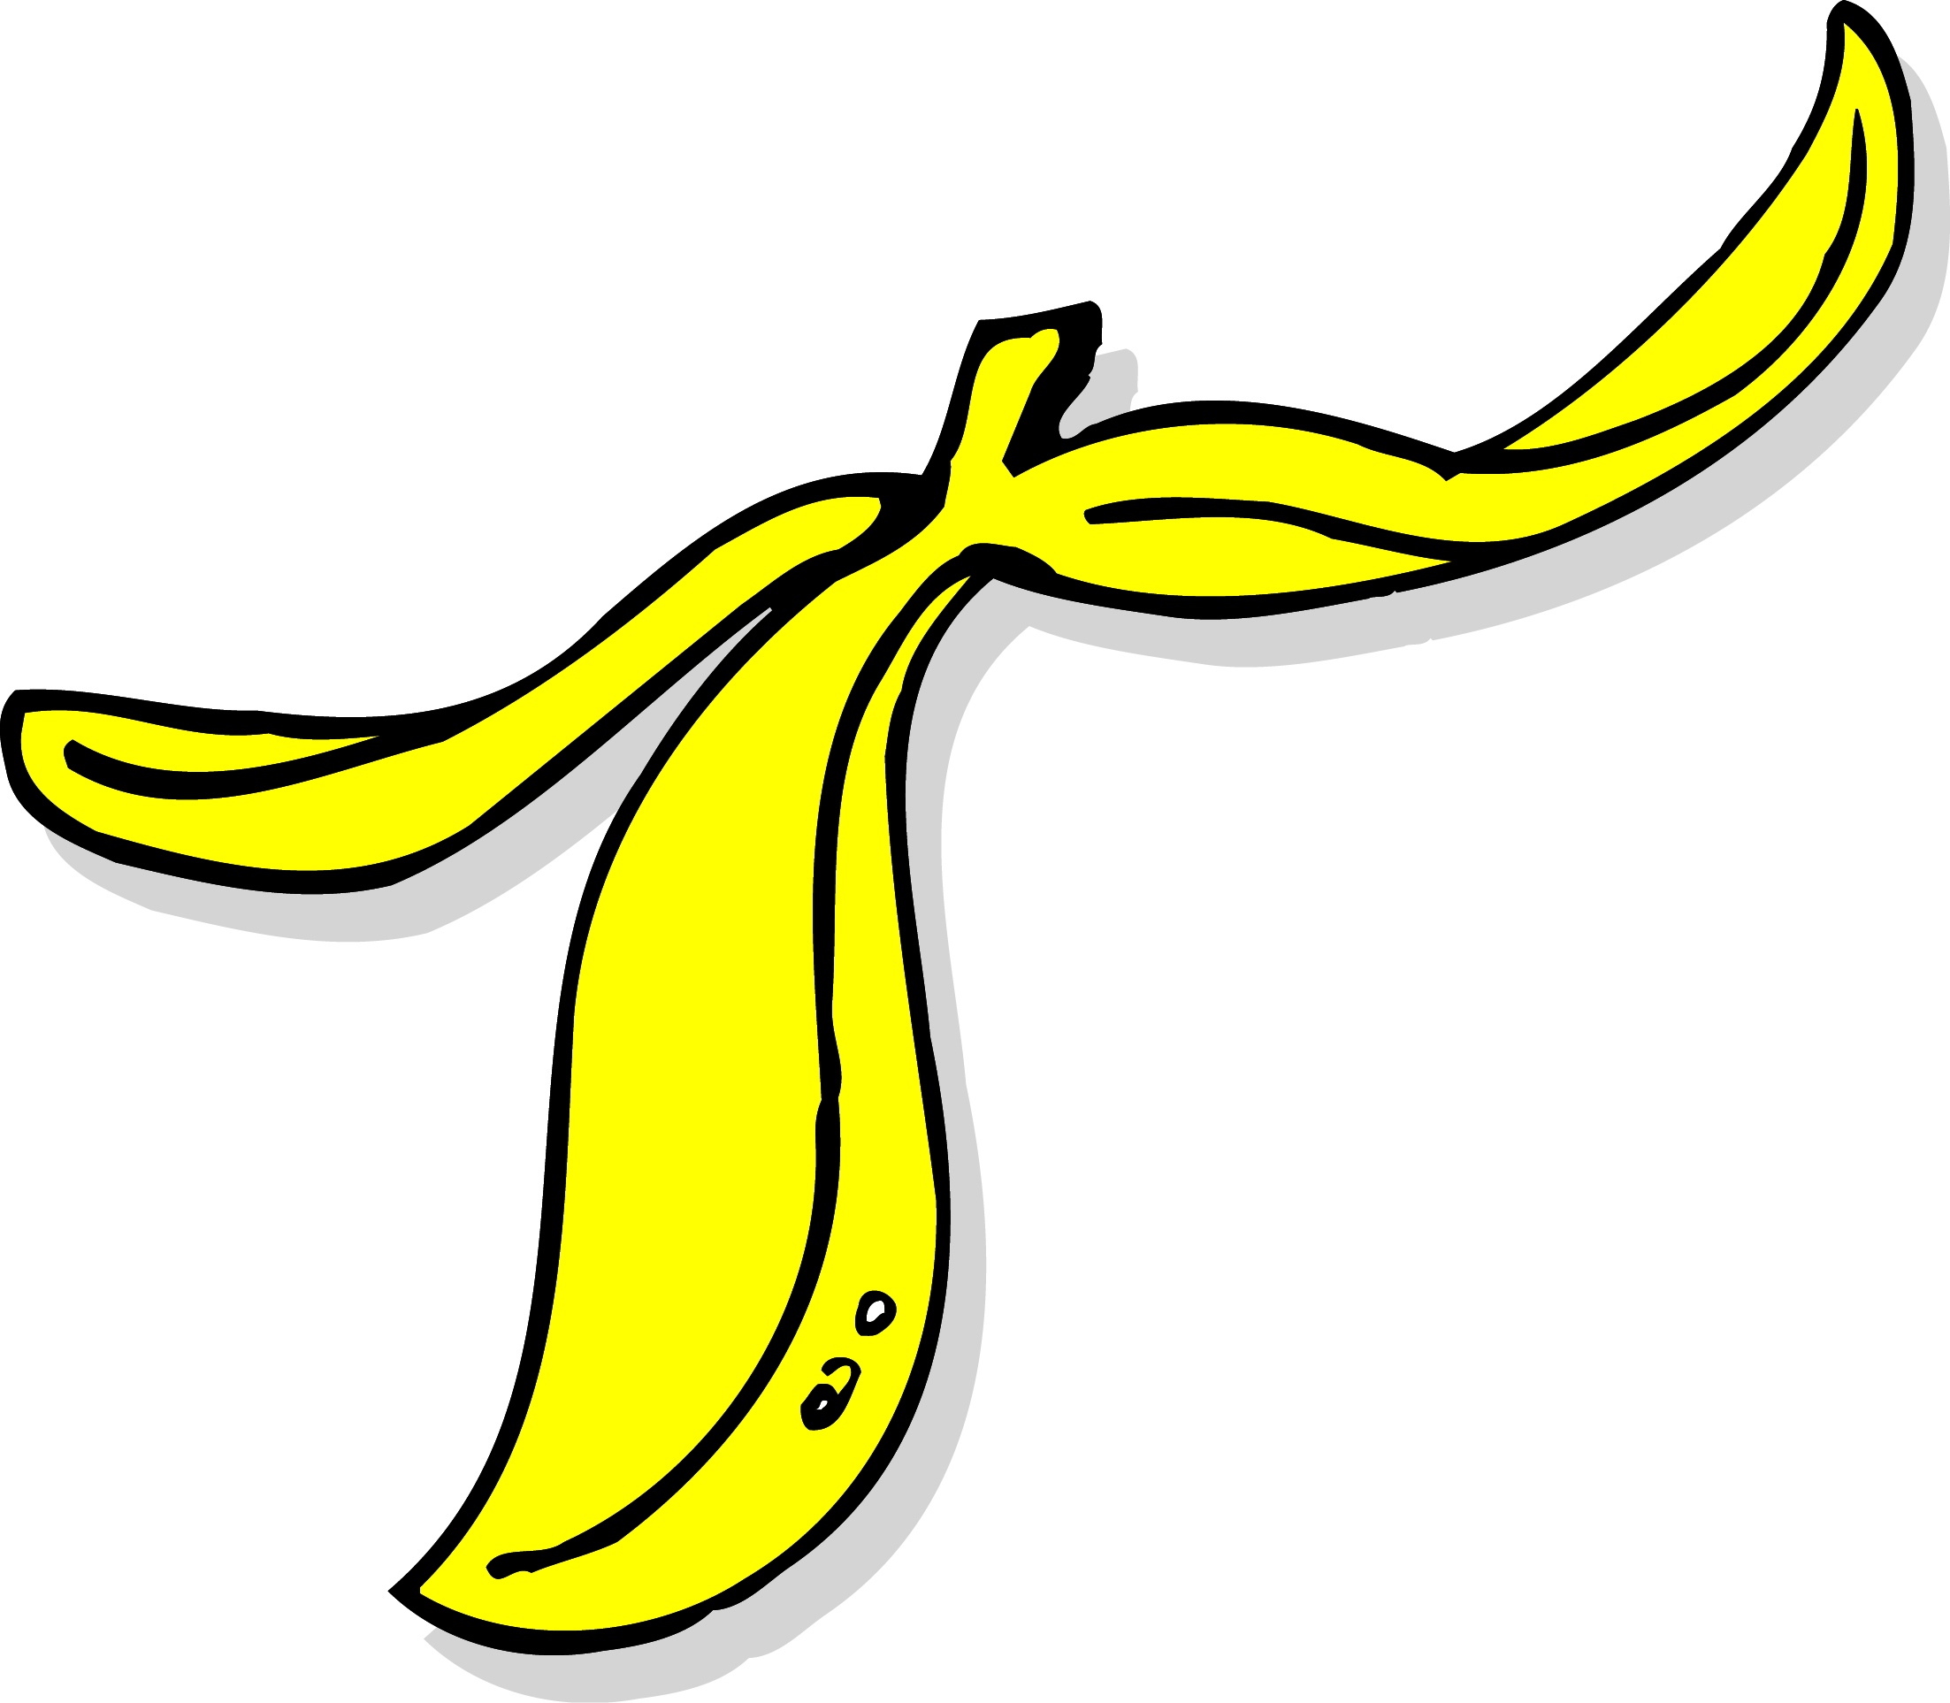
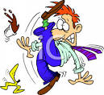

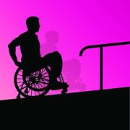
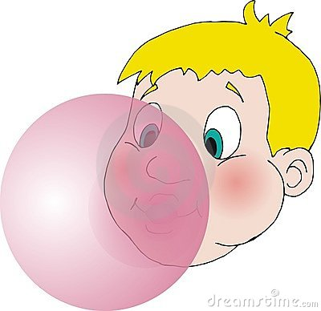
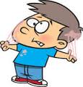

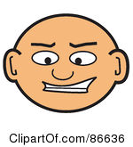
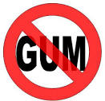
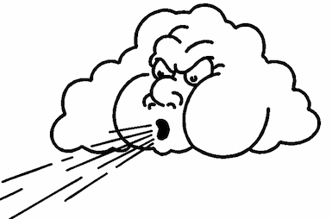


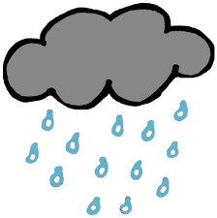

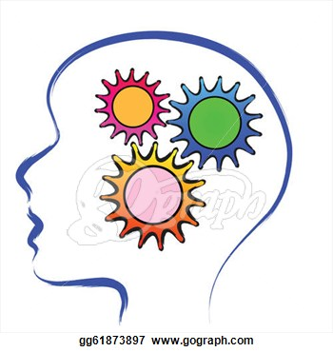

Name_________________
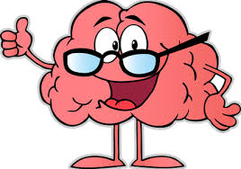

EXIT SLIP

Today’s lesson was about______________________________________________________.

What were the learning goals today?______________________________________________
___________________________________________________________________________________________________________________________________________________________________________________________________________________________________________________________________________________________________________________________________________________________________________________________.

Why do you think it is important to meet these goals?_________________________________
_______________________________________________________________________________________________________________________________________________________.

Rate how you felt about meeting the learning goals today. Circle One.
4 – I understood it very well; 3 – I understood it, but sometimes I got stuck; 2 – I’m starting to get it, but still need help; 1 – I really don’t understand it yet.

I choose… 4 3 2 1

Something I understood today was________________________________________________
_______________________________________________________________________________________________________________________________________________________.

Something I did not understand was_______________________________________________
_______________________________________________________________________________________________________________________________________________________.

Something that helped me learn today was__________________________________________
___________________________________________________________________________.

